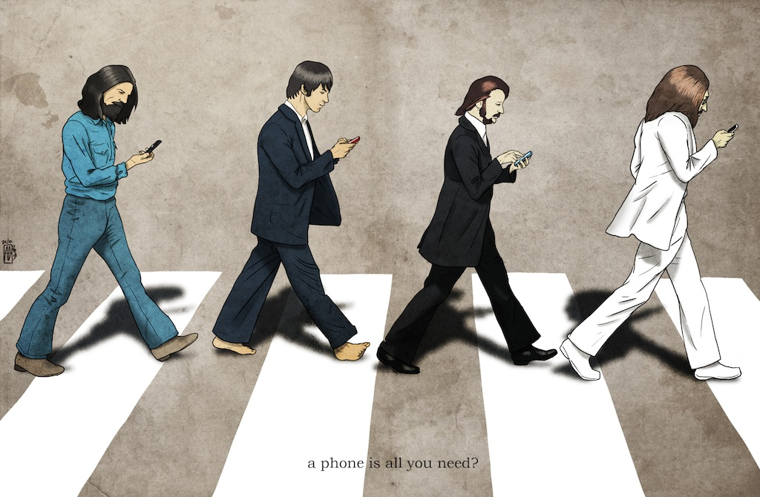

Photo by: **CreativeAbzy** on <https://www.deviantart.com/creativeabzy>

This photo was inspired by The Beatle’s Abbey Road album cover, which is provided below for comparison. I chose this as my metaphor for globalization because the mobile phone is a product of the rapid integration of technologies that brought about even more interconnectedness of people all around the world.

